# Procedure

## Blasting and Coating Best Management Practices (BMP) Plan

**OPS0191-PR01 Procedure**

**Blasting and Coating Best Management Practices (BMP) Plan**

1. [General Requirements](#B1_GenReq)
2. [General BMP](#B2_AdminReq)
3. [Zone Descriptions and Containment Control Options](#B3_Zones)
4. [General Requirements for All Activities](#B4_Activity_GenReq)
5. [Abrasive Blasting BMP](#B5_AbrasiveBlast)
6. [Water Blasting BMP](#B6_WaterBlast)
7. [Surface Coating BMP](#B7_SurfaceCoating)
8. [Photos](#B8_Photos)
9. [Photos](#B8_Photos)

**Tools**

* [Glossary (TO.01)](#PR01_TO01)
* [Reference and Companion Documents (TO.02)](#PR01_TO02_References)
* [Blasting and Coating BMP Plan Statement of Approval (TO.03)](#PR01_TO03_Blasting_and_Coating_BMP)
* [Blasting and Coating BMP Plan Inspection Form (TO.04)](#PR01_TO03_Blasting_and_Coating_Inspectio)
* [Blasting and Coating BMP Plan Feedback Form (TO.05)](#PR01_TO05_Feedback_Form)
* [Blasting and Coating BMP Plan Training Documentation Form (TO.06)](#PR01_TO06_Training_Documentation_Form)
* [Blasting and Coating BMP Plan Media Use and Recovery Form (TO.07)](#PR01_TO07_Media_Use_Recovery)
* [Zones of Offshore Facilities (TO.08)](#PR01_TO08_Zones_Offshore_Facilities)

Document Suite Map

### 1 General Requirements

|  |  |
| --- | --- |
| 1.1 Purpose and Applicability | Using containment and capture strategies, this Best Management Practices (BMP) Plan restricts discharge of abrasives and paint residues/overspray to surrounding waters during maintenance coating operations. It applies for all DW facilities in the Gulf of Mexico (GOM).  Due to possibility of multiple owners for drilling rigs, DW-GOM will apply one of the following on a case-by-case basis for each rig/lease block:   1. Rig owner gains coverage under the EPA NPDES General Permit and develops a specific painting and sandblasting BMP plan. All other discharges are covered by Lease Holder’s (Operator’s) permit.\* 2. Rig owner performs painting and sandblasting under DW-GOM’s BMP plan as agreed by the owner and DW-GOM. 3. Rig owner develops a specific BMP plan and (if DW-GOM concurs) discharge occurs under DW-GOM’s permit.   For co-located rigs, option 2 will be followed, and for floating rigs, option 1 will be followed. Consult Environmental Engineer if deviation is needed.  \*Cooling Water Intake Structure requirements in the NPDES Permit may also be under the rig owner’s permit coverage. See HSE0051Federal OCS Waters (Western GOM) Environmental Compliance Manual for more information. |

|  |  |
| --- | --- |
| 1.2 BMP Scope and Overall Objectives | This plan was developed to comply with BMP Plan requirements in Part I, Section C.6 of NPDES General Permit GMG290000 (Final NPDES General Permit for New and Existing Sources and New Dischargers in the Offshore Subcategory of the Oil and Gas Extraction Category for the Western Portion of the Outer Continental Shelf of the Gulf of Mexico). It is based on the following regulatory requirements, industry codes, practices, and guidelines:   * EPA 833-B-98-004 Guidance Manual for Developing Best Management Practices * Bureau Of Safety And Environmental Enforcement of the U.S Department of the Interior (30 CFR 250). * U.S. Coast Guard - U.S. Coast Guard (46 CFR Subchapter I-A) * MARPOL Annex V - MARPOL Annex V regulations (33 CFR 151, subpart A) * American Petroleum Institute - (API) Bulletin 91, First Edition, June 2007. * National Association of Corrosion Engineers International (NACE) |

### 2 BMP Plan – Administrative Requirements

|  |  |
| --- | --- |
| 2.1 BMP Plan Committee and Statement | The BMP committee is made up of the:  Maintenance Delivery Manager (responsible for maintenance painting of platforms and associated production facilities)  Wells Delivery Manager(s) (responsible for NPDES Permit compliance of drilling rigs and associated structure/equipment)  Environmental Manager (responsible for all other aspects of environmental compliance at DW locations).  This committee:  is responsible for BMP Plan review, implementation and modification, and  evaluates the plan every 5 years (minimum) and amends the plan promptly, if warranted. Significant changes occurring between formal review periods may warrant additional plan review/approvals.  Following each BMP Plan Committee review, committee findings (either re-approval or need for modification) will be saved and available for inspection as OPS0191-PR01-TO.03 Blasting and Coating BMP Plan Statement of Approval. The most recent version of OPS0191-PR01-TO.03 is retained as part of OPS0191, and previous the version discarded. |

|  |  |
| --- | --- |
| 2.2 Plan Modification | Where modifications are required, action plans with responsible parties will be developed with a goal of implementing improvements within three months of Plan review.  Plan modification triggers include, but are not limited to:  Change in surface preparation or coating operations significantly affecting potential for discharge of spent blast abrasive, paint chips, and paint overspray  Plan is determined ineffective in achieving the BMP objectives (i.e. a significant release resulting from failure of BMP plan controls)  Inspections reveal that procedures or equipment should be modified to further reduce potential for releases |

|  |  |
| --- | --- |
| 2.3 BMP Stakeholder Input | All personnel involved with surface preparation and coating operations are encouraged to suggest improvements using OPS0191-PR01-TO.05 Blasting and Coating BMP Plan Feedback Form. Completed feedback forms are given to the on-site surface preparation and coating operations Person in Charge (PIC) and forwarded to the BMP Plan Committee for periodic review. Plan questions can be directed to any BMP Plan committee member. |

### 3 Zone Descriptions and Containment Control Options

|  |  |
| --- | --- |
| 3.1 Introduction | Techniques used to contain and control blasting/coating discharges vary based on the activity zone. The three activity zones are indicated below and described in the following sections. See Figures 1-6 in OPS0191-PR01-TO.08 Zones of Offshore Facilities for additional information.  Rig Image.jpg  **Zone 1**  **Zone 2\***  **Zone 3**  \*NOTE: Areas that extend outward or that are elevated above Zone 3 (e.g. flare or vent boom, crane boom, rig frame, heliport, drilling derrick) are considered Zone 2. |

|  |  |
| --- | --- |
| 3.2 Zone 1 | Zone 1 is the area below the waterline. This BMP does not address surface preparation and coating applications in Zone 1. |

|  |  |
| --- | --- |
| 3.3 Zone 2 | Zone 2 generally encompasses the area below Zone 3 extending to the water line and includes areas that extend outward or that are elevated above Zone 3 (e.g. flare or vent boom, crane boom, rig frame, heliport, drilling derrick). Figures 1-6 in OPS0191-PR01-TO.08 illustrate Zone 2 for various installation types. The following controls should be used to minimize Zone 2 discharges:  Blast abrasive washing and self-contained abrasive blaster, where appropriate,  Good housekeeping and collection of waste  Operation and maintenance controls for equipment, including careful pressure regulation and routine inspection/replacement of blasting and paint application nozzles  Ceasing operations during adverse weather conditions  Proper coating selection to decrease frequency of coating and minimize overspray  Applying optimum number of coats  Controls are detailed in Sections 5, 6, and 7. |

|  |  |
| --- | --- |
| 3.4 Zone 3 | Zone 3 extends from the bottom deck up to and including the top deck, with exceptions as specified for Zone 2. Figures 1-6 in OPS0191-PR01-TO.08 illustrate Zone 3 for various installation types.  All controls in Zone 2 apply to Zone 3. In addition, the following should be used in Zone 3:  Containment pads, trays, skids, decking, etc.  External containment (tarps, plastic sheeting and plywood)  Sealed seams for external containment joints  Covered skid pans while working  Plugs or filters for drains  Frequent removal of spent abrasives, removed materials, and water  Vacuum blasting, where appropriate  Controls are detailed in Sections 5, 6, and 7. |

|  |  |
| --- | --- |
| 3.5 Specific Activities Addressed by this Plan |  |

|  |  |
| --- | --- |
| Topic | Reference |
| Abrasive Blasting | Refer to Section 5.0 for controls. |
| Water Blasting | Water blasting may be used as an alternative to abrasive blasting. Refer to Section 6.0 for controls. |
| Surface Coating | Coating operations generate the following 3 wastes:  paint residues,  paint overspray, and  coating supplies that can no longer be used.  This plan addresses paint residues and overspray. Coating supplies that can no longer be used must be handled according to owner/operator specific waste management procedures and applicable regulatory requirements (See HSE0131 Waste Management).  Refer to Section 7.0 for surface coating controls. |

### 4 General Requirements for All Activities Addressed by this Plan

|  |  |
| --- | --- |
| 4.1 Good Housekeeping | Work areas must be maintained clean and orderly during normal operations to minimize potential for releases. Practices include, but are not limited to:  promptly addressing leaks and spills,  inspecting work areas and pathways for clutter and related hazards,  storing and labeling materials properly  Housekeeping practices are included in BMP plan training. |

|  |  |
| --- | --- |
| 4.2 Inspections | Routine visual inspections shall be performed daily and documented at least weekly (or once per job if shorter than a week). Inspections shall be documented using OPS0191-PR01-TO.04 Blasting and Coating BMP Plan Inspection Form, and inspection deficiencies must be promptly corrected. |

|  |  |
| --- | --- |
| 4.3 Pollution Prevention and Reporting | All pollution-prevention activities noted in this plan must be performed to the maximum extent practicable (MEP).  Discharge of visible foam and/or any sheen on the Gulf surface from an offshore platform or vessel is prohibited. If sheen or foam is observed, it must be reported to Shell leadership (Job Sponsor, etc.) whether or not the sheen/foam resulted from blasting/coating activities. See HSE0051-PR01-TO.01 OCS Pollution Reporting Procedures Field Guide for details.  If any equipment and/or materials are lost overboard, notify Shell leadership and follow reporting requirements in HSE0051-PR01-TO.01 OCS Pollution Reporting Procedures Field Guide. |

|  |  |
| --- | --- |
| 4.4 Operational Controls, Pressure Regulation and Routine Inspection/ Replacement of Nozzles | Proper operation and maintenance of equipment can minimize the amount of blasting material used (reducing waste) and minimizes equipment-related spills/leaks.  Nozzles must be maintained in proper operational condition to optimize blasting flow rates and paint application rates. Compressors and pumps operating blast and paint-application nozzles must be periodically checked to verify that nozzles are operated at the manufacturer’s recommended pressure (see photos in 8.1 Abrasive Blasting Material and Equipment). |

|  |  |
| --- | --- |
| 4.5 Sump System and Skid Pan Management | Upsets or mismanagement of the sump and drain system can lead to NPDES Permit Noncompliance. It is very important to prevent sand, soaps, or other materials from entering drains and skid pans. If any of these materials are found in a skid pan, the pan must be cleaned out before the drain plug is removed.  While skid pans remain plugged for blasting/coating activities they shall be kept free of contaminants and debris. When rainy conditions are anticipated, the plugged skid pans shall be cleaned and covered, if possible. If covering is not possible, drain plugs should be removed to prevent overflow of skid pan due to rainfall. |

|  |  |
| --- | --- |
| 4.6 Waste Minimization and Disposal | During planning, the amount of paint, abrasives and other materials needed for a project should be carefully evaluated to minimize the amount of excess material likely to remain after project completion.  Wastes resulting from blasting and coating operations (abrasives, brushes, empty paint buckets, protective clothing, masks, etc.) shall be collected, properly stored, and disposed of in accordance with HSE0131 Waste Management. |

|  |  |
| --- | --- |
| 4.7 Blasting Frequency | Blasting operations are conducted at the frequency identified by the DW-GOM maintenance program, or during periodic/annual surveys. |

|  |  |
| --- | --- |
| 4.8 Weather Conditions | Careful attention should be paid to weather conditions if the work area is subject to rain and wind. If heavy rains or high winds are forecast, the operations PIC shall determine if conditions pose a threat to personnel safety or render the containment systems ineffective. During unacceptable conditions, abrasive blasting, water blasting, and coating operations must cease. |

|  |  |
| --- | --- |
| 4.9 Record Keeping | Records will be kept as follows: |

|  |  |
| --- | --- |
| Record | Location |
| Master copy of the BMP and Committee Reviews | Maintained electronically in the DW-GOM Controlled Document system |
| Inspection records | Copy maintained in job file and copy sent to  DW-GOM Environmental Engineering for electronic storage |
| Training records | Copy maintained by contractor and copy sent to DW-GOM Environmental Engineering for electronic storage |
| Plan Modification records | Changes will be documented in the BMP Revision Record |
| BMP Plan Media Use and Recovery Form | Copy maintained in job file and copy sent to DW-GOM Environmental Engineering for electronic storage |

|  |  |
| --- | --- |
|  | Records are available to EPA-authorized representatives for inspection upon request. |

|  |  |
| --- | --- |
| 4.10 Training | Initial BMP training covers plan requirements, objectives, and purpose. Training is given to all individuals who perform blasting and coating operations plus appropriate facility personnel (particularly HSE technicians) and contractor supervisors. Once trained, location HSE tech(s) may provide BMP training to others.  Supplemental training is performed as needed when there is a change in facility or contractor personnel, a recurring problem, or a significant BMP plan modification.  Training is documented using OPS0191-PR01-TO.06 Blasting and Coating BMP Plan Training Documentation Form. |

|  |  |
| --- | --- |
| 4.11 Work Permits | All work shall be performed using HSE0008 Safe Work Planning and Authorization (SWPA). |

### 5 Additional Requirements - Abrasive Blasting BMP

|  |  |
| --- | --- |
| 5.1 Types of Blast Abrasive | Abrasives should be evaluated on a case-by-case basis to determine cost-effectiveness and ability to meet required performance standards. Garnet is the most common blast abrasive used by DW-GOM and is available in many particle size grades to suit various job needs.  For each blast abrasive used, a MSDS must be obtained and reviewed to determine potential risk to human health/environment, PPE requirements, and waste disposal options (see photos in 8.1 Abrasive Blasting Material and Equipment). |

|  |  |
| --- | --- |
| 5.2 Abrasive Handling | Before starting work, blast abrasive shall be dispensed or transferred from transport containers to the blast pot (see photos in 8.1 Abrasive Blasting Material and Equipment). Grating under and around the blast pot shall be covered with plywood or other secured solid flooring. The transfer process shall minimize spillage and dust emissions. Spillage shall be recovered for reuse or disposed as appropriate (see photos in 8.2 Blast Abrasive Transfer and Containment). |

|  |  |
| --- | --- |
| 5.3 Control and Containment of Spent Blast Abrasives | Operational controls, barriers, containment structures, or a combination must be used to prevent abrasives discharge from the work area. Spent blast abrasive must be contained and collected regularly, not left to accumulate over the course of a job (see photos in 8.2 Blast Abrasive Transfer and Containment). It must then be disposed or reused, depending on type. Follow HSE0131 Waste Management.  Additional technology that may be used include Minnie BRS vacuum blasters on the hull exteriors (dry abrasive spot blast) followed by spot painting and over coat the existing coating system. This system recycles the material and has a dust collector to collect all the fines. The fines are collected in a holding bin in the system that requires being emptied periodically. When emptied the fines will be recovered and managed for proper disposal ashore. |

|  |  |
| --- | --- |
| 5.4 External Containment | External containment shall be used for blasting where practical and safe. Containment structure shall be as close as practical to the blast area. It should consist of walls, ceiling, flooring, and closable, clearly-marked ingress/egress as appropriate with either a rigid or flexible frame. Control methods/techniques shall ensure containment (see photos in 8.2 Blast Abrasive Transfer and Containment).  Containment and/or controls shall be maintained throughout the course of surface preparation in accordance with approved design. |

|  |  |
| --- | --- |
| 5.5 Sealed Joints | Walls, ceiling, and flooring of the containment structure shall have overlapping sealed seams to minimize escape of spent blast abrasive (see photos in 8.2 Blast Abrasive Transfer and Containment). |

|  |  |
| --- | --- |
| 5.6 Lead-Based Paint | If lead-based paint is found or suspected, contact the Painting Activity Coordinator who will request personal protection and remediation procedures from Industrial Hygiene. Lead-based paint is not used on DW-GOM’s facilities. For questions or concerns at a particular location, contact the Painting Activity Coordinator. |

|  |  |
| --- | --- |
| 5.7 Other Controls | The following table lists other specific controls for spent blast abrasives. |

|  |  |
| --- | --- |
| Washed Blast Abrasive | Washing is rarely required as Shell uses clean abrasive with minimal fines. |
| Self-Contained Abrasive Blaster | A self-contained abrasive blasting unit that re-circulates the blast abrasive can be used on large flat surfaces (See photo in 8.3 Self-Contained Blast Abrasive Unit). |
| Sump System Management | Where possible, skid pans shall be covered during blasting activities. The PIC or Job Sponsor is responsible for ensuring that skid pans are cleaned before drain plugs are removed or job is concluded. |
| Packaging of Spent Blast Abrasive | Once collected, spent blast abrasive shall be stored in an appropriate container (see photos in 8.4 Packaging of Spent Blast Abrasive). |
| Storage of Spent Blast Abrasive | Spent abrasive shall be stored in contained areas designated for storage. Periodic storage area inspections shall be conducted to ensure proper containment and control. |
| Disposal of Spent Blast Abrasive | Spent blast abrasive must be transported off-site for disposal in accordance with applicable regulations. Any spills during transportation shall be evaluated to determine if a regulatory Reportable Quantity (RQ) has been released. If a RQ has been released, notification must be made to the regulatory authority. See HSE0131 Waste Management for requirements. |
| Spent Media Recovery Tracking | Each job will track spent and recovered media using OPS0191-PR01-TO.07 Blasting and Coating BMP Plan Media Use and Recovery Form. This enables recovery efficiencies to be tracked. |
| HoldTight 102 (HT 102) | HoldTight 102 (HT 102) is a surface decontamination/rust inhibitor product that may be used from time to time. Its use provides a more consistent surface decontamination during cleaning, and a longer period of time before flash rust sets (in case of delayed coating work) thereby reducing the need to re-blast (and so reducing blast media usage overall).  Although Shell does not believe this is a strict requirement given this product is used per the BMP, for conservatism, the HT 102 will be routinely checked under the provisions of the EPA GMG290000 permit as a “chemically treated fresh water” discharge. Shell will work with the vendor to ensure an annual toxicity test is performed on neat fluid for representative conditions of use (expected concentrations, discharge rates, etc., which are expected to be uniform across the GOM). Shell Environmental team has the lead to track this testing. Initial toxicity testing (April 2015) per GMG290000 showed compliant results well above the expected critical dilution.  HT 102 does not foam nor cause a sheen on surface waters. |
| Vapor Blasting  **(Water mist with Garnet abrasive)** | * Will reduce airborne nuisance dust (abrasives) to the environment * Less exposure of nuisance dust to personnel * Less pollution to environment using potable water vs dry abrasive * Less damage to equipment from airborne dust |
| Self-Contained Abrasive Blaster | A self-contained abrasive blasting unit that re-circulates the blast abrasive can be used on large flat surfaces (See photo in 8.3 Self-Contained Blast Abrasive Unit). |

### 6 Additional Requirements - Water Blasting BMP

|  |  |
| --- | --- |
| 6.1 Water Blasting Techniques | Water blasting is typically for jobs where ambient dust could damage nearby machinery. Depending on required surface cleanliness, water blast pressures can range from 5,000 to more than 15,000 psi.  Ultra High Pressure Water Jetting Techniques (UHP) to above 25,000 to 55,000 psi may be used. This blasting technique has the following benefits over dry abrasive blasting:  Will reduce airborne nuisance dust (abrasives) to the environment  Less exposure of nuisance dust to personnel  Less pollution to environment using potable water vs dry abrasive  Less equipment protection, labor to install & change  Less damage to equipment from airborne dust |

|  |  |
| --- | --- |
| 6.2 Discharge Reduction Measures | Water blasting control measures shall consist of operational controls, barrier or containment, or a combination to minimize discharges from the work area. Potential external containment structures could include tarps, sheeting, etc. (see photos in 8.5 Blast Abrasive Transfer and Containment [Water Blasting]). |

|  |  |
| --- | --- |
| Plugs/Filters for Drain Systems | Plugs/filters should be used to isolate or protect drainage lines and ensure that blast water is not introduced to the wastewater treatment system (see photos in 8.6 Drain Line Plugs). |
| Spent Blast Water | Due to infrequent use and close quarters typically associated with water blast jobs, spent blast water is not typically collected (low contamination potential). |

|  |  |
| --- | --- |
| 6.2 Discharge Reduction Measures | Water blasting control measures shall consist of operational controls, barrier or containment, or a combination to minimize discharges from the work area Potential external containment structures could include tarps, sheeting, etc. (see photos in 8.5 Blast Abrasive Transfer and Containment [Water Blasting]). |

|  |  |
| --- | --- |
| UHP | In Zone 3, Ultra High Pressure Water Jetting control measures shall consist of operational controls, barrier or containment, or a combination to minimize discharges of overspray and solids from the work area. Potential external containment structures could include tarps, sheeting, etc.  Paint chips & rust removed during UHP surface preparation will include use of filter type barriers in drain troughs, drain pans, skid pans, etc. The filter material will capture paint chips & debris while allowing water to pass on to discharge.  Containment screens, tarps or rubber matting may also be used to control flying debris.  Paint chips and debris shall be recovered for proper disposal ashore. |

### 7 Additional Requirements - Surface Coating BMP

|  |  |
| --- | --- |
| 7.1 Selection | Coatings and coating supplies are selected based on documented performance history, surveys, and intended use. |

|  |  |
| --- | --- |
| 7.2 Application Method | Coatings shall be applied using the manufacturer’s recommendations and DW-GOM practices as defined in ENG0080SP Coatings and Markings (Schedule P).  Between coats, dry surfaces are washed with seawater to remove dust and de-minimis (minimal amounts of) wind-borne particulate adhering to the surface. This water is not collected (low potential for contamination). |

|  |  |
| --- | --- |
| 7.3 Discharge Reduction Options | Coating control measures shall consist of operational controls, barriers, containment, or a combination that minimize discharges from the work area (see photos in 8.7 Painting Containment). |

|  |  |
| --- | --- |
| 7.4 Painting at the Water Line | When painting at or near the water line, some portion of paint spray may reach the water due to wind and proximity to sea surface. When the BMP plan is followed correctly by trained personnel, the amount of paint reaching the water is de minimis. If paint is spilled or sprayed directly into the water in any amount, follow HSE0051-PR01-TO.01 OCS Pollution Reporting Procedures Field Guide for spill reporting.  To minimize windblown paint spray and protect worker safety, painting should not take place at or near the water line during windy conditions. The offshore Paint Foreman and Shell leadership will jointly consider this during job planning. |

### 8 Photos

|  |  |  |
| --- | --- | --- |
| 8.1 Abrasive Blasting Material and Equipment | The following photos emphasize aspects of abrasive blasting material and equipment. | |
|  | Photo 19.jpg  Blast Pot Pressure Gauge | Photo 20.jpg  Used and New Blast Abrasive Nozzle |
|  | Photo 21.jpg  Blast Abrasive Nozzle Gauge | Photo 01.jpg  Personal Protective Equipment (PPE) |
|  | Photo 02.jpg  PPE Including Supplied Air | 100_1158.jpg  Unused Blast Abrasive |

|  |  |  |
| --- | --- | --- |
| 8.2 Blast Abrasive Transfer and Containment | The following photos emphasize aspects of blast abrasive transfer and containment. | |
|  | New, Unused Blast Abrasive Being Transferred from Hopper to Blast Pot | |
|  | Photo 04.jpg  Containment Below the Blast  Abrasive Pressure Vessel | Photo 22.jpg  Housekeeping Inside the Blasting  Containment Area |
|  | Photo 06.jpg  Blast Abrasive External Containment  Being Installed | Photo 07.jpg  Blast Abrasive External Containment  Being Installed II |
|  | Photo 08.jpg  Blast Abrasive External Containment | Photo 09.jpg  Blast Abrasive External Containment II |
|  | Photo 10.jpg  Blast Abrasive External Containment III | Photo 11.jpg  Overlapping Walls with Designated  Entrance to the Blasting Area |
|  | Photo 14.jpg  Overlapping Walls with Designated Exit from the Blasting Area | Photo 12.jpg  Overlapping Walls with Designated Exit from the Blasting Area II |
|  | Photo 13.jpg  Emergency Exit in Blasting Area | |
|  | Photo 15.jpg  Plywood Flooring for Containment Area | Photo 16.jpg  Overlapping Containment Wall Secured Together in the Blasting Area |
|  | Photo 17.jpg  Plywood Flooring in the Containment Area | Photo 18.jpg  Close-up of Sealed Joints between  Plywood Flooring in Containment Area |

|  |  |
| --- | --- |
| 8.3 Self-Contained Blast Abrasive Unit | The following photo depicts a self-contained blast abrasive unit.  Photo 23.jpg  Self-Contained Blast Abrasive Unit |

|  |  |  |
| --- | --- | --- |
| 8.4 Packaging of Spent Abrasive | The following photos depict the collection and storage of spent abrasive. | |
|  | Photo 24.jpg  Collection of Spent Abrasive in  Containment Area | E:\Users\kenneth.ballard\AppData\Local\Microsoft\Windows\Temporary Internet Files\Content.Outlook\28NM0Q2X\Photo 26.jpg  Spent Abrasive Storage |

|  |  |
| --- | --- |
| 8.5 Blast Abrasive Containment (Water Blasting) | The following photo depicts containment and PPE for water blasting.  Photo 26.jpg  Water Blasting Showing Containment  Structure and PPE |

|  |  |  |
| --- | --- | --- |
| 8.6 Drain Line Plugs | The following photos depict drain line plugs. | |
| Photo 27.jpg  Plug to Isolate Drainage Line | Photo 28.jpg  Plug Installed to Isolate Drainage Line |

|  |  |  |
| --- | --- | --- |
| 8.7 Painting Containment | The following photos depict elements of painting containment. | |
| Photo 29.jpg  Paint Containment Structure | Photo 30.jpg  Paint Containment Structure II |
| Photo 31.jpg  Painting in Contained Area | |

# TOOL OPS0191-PR01-TO.01

### Glossary

|  |  |
| --- | --- |
| Term / Acronym | Definition |
| Abrasive blasting | The operation of cleaning or preparing a surface by forcibly propelling a stream of abrasive material against the surface. |
| API | American Petroleum Institute |
| BSEE | Bureau of Safety and Environmental Enforcement |
| Containment system | Cover panels, screens, tarps, scaffolds, plywood, supports, and shrouds used to enclose an entire work area or coating removal tool. The purpose is to minimize or prevent spent blast abrasive generated during surface preparation from entering into the environment, and to facilitate the controlled collection of the spent blast abrasive for disposal. |
| Discharge | Any spilling, leaking, pumping, pouring, emitting, emptying, or dumping, but excluding the following:   * Discharges in compliance with a permit under Section 402 of the Clean Water Act, * Discharges resulting from circumstances identified and reviewed and made part of the public record with respect to a permit issued or modified under Section 402 of the Clean Water Act, and subject to a condition in such permit, and * Continuous or anticipated intermittent discharges from a point source, identified in a permit or permit application under section 402 of the Clean Water Act, which are caused by events occurring within the scope of relevant operating or treatment systems. [33 CFR 153.103(g)] |
| Maintenance waste | Materials collected while maintaining and operating the ship, including, but not limited to, soot, machinery deposits, scraped paint, deck sweepings, wiping wastes, and rags. [33 CFR 151.05] |
| MARPOL 73/78 | The International Convention for the Prevention of Pollution from Ships, 1973, as modified by the Protocol of 1978 relating to that Convention. (33 CFR 151.05) |
| MSDS | Material Safety Data Sheets |
| Maximum extent practicable (MEP) | For the purpose of this document, the MEP is a level of implementing best practices in order to achieve a performance standard which takes into account available technology, cost effectiveness and other essential issues such as human safety. MEP allows flexibility in the way to meet the performance standards and may vary based on site conditions. |
| NACE | National Association of Corrosion Engineers |
| Operator | The individual, partnership, firm, or corporation having control or management of operations on the lease or a portion thereof. The operator may be a lessee, designated agent of the lessee, or holder of rights under an approved operating agreement. |
| Owner | Any person holding title to or, in the absence of title, other indicia of ownership of a unit; however, this does not include a person who holds indicia of ownership primarily to protect a security interest in the unit and does not participate in the management or operation of the unit. (33 CFR 140.10) |
| Spent blast abrasive | Blast abrasive that has been used and as the result of that use is no longer useful for its intended purpose. |
| Water blasting | Any abrasive blasting using high-pressure liquid as the propelling force for surface preparation. |

# TOOL OPS0191-PR01-TO.02

### References and Companion Documents

|  |  |
| --- | --- |
| Companion Documents | Business control documents in this suite are listed in the table below. |

|  |  |
| --- | --- |
| Document Number | Title |
| OPS0191-PR01 | Blasting and Coating Best Management Practices Plan |
| OPS0191-PR01-TO.01 | Glossary |
| OPS0191-PR01-TO.02 | References and Companion Documents |
| OPS0191-PR01-TO.03 | Blasting and Coating BMP Plan Statement of Approval |
| OPS0191-PR01-TO.04 | Blasting and Coating BMP Plan Inspection Form |
| OPS0191-PR01-TO.05 | Blasting and Coating BMP Plan Feedback Form |
| OPS0191-PR01-TO.06 | Blasting and Coating BMP Plan Training Documentation Form |
| OPS0191-PR01-TO.07 | Blasting and Coating BMP Plan Media Use and Recovery Form |
| OPS0191-PR01-TO.08 | Figures and Zones of Offshore Facilities |

|  |  |
| --- | --- |
| Reference Documents | the following documents, practices and procedures relating to Good Housekeeping; Preventative Maintenance; Record Keeping; Inspections; Training and Waste Minimization and Management are incorporated by reference |

|  |  |
| --- | --- |
| Shell Documents | |
| Document Number | Title |
| ENG0080SP | Coating and Markings (Schedule P) |
| Regulatory Documents | |
| Document Number | Title |
| 29 CFR 1910.94 | Occupational Safety and Health Administration Program Respiratory Protection Regulations |
| 33 CFR 151, Subpart A | MARPOL Annex V - MARPOL Annex V regulations |
| GMG290000 | Final NPDES General Permit for New and Existing Sources and New Dischargers in the Offshore Subcategory of the Oil and Gas extraction Category for the Western Portion of the Outer Continental Shelf of the Gulf of Mexico, October 2007. |
| Industry Documents | |
| Document Number | Title |
| API RP 74 | Recommended Practice for Occupational Safety for Onshore Oil and Gas Production Operations |
| API Bulletin 91 | Planning and Conducting Surface Preparation and Coating Operations for Oil and Natural Gas Drilling and Production Facilities in a Marine Environment, First Edition, June 2007. |
|  | Recommended Management Practices for Abrasive Blasting, Gulf Coast States Abrasive Blasting Committee, August 2000. |

# TOOL OPS0191-PR01-TO.03

### Blasting and Coating BMP Plan Committee Statement of Approval

A review of this BMP Plan has been completed by the BMP Committee listed below. These individuals are responsible for:

* developing,
* implementing,
* monitoring to ensure that Plan objectives and specific requirements are met, and
* revising the Plan when needed.

This Plan fulfills the BMP Plan requirements of Part I, Section C.6 in NPDES General Permit GMG 290000.

|  |  |  |
| --- | --- | --- |
| NAME | TITLE | APPROVAL VERIFICATION |
| Skip Koshak | UAD Environmental and UA Legacy Manager | Electronic Approval |
| Alan Marsack | General Manager Wells - GOM | Electronic Approval |
| Ton Van Den Heuvel | UAD Manager,  Maintenance and Integrity | Electronic Approval |

BMP Plan review was completed on **17 June 2014**.

(Date)

Plan has been updated and is approved; modification is not required.

Plan modification is required. Modifications must be made and implemented within 3 months of the above review date.

|  |  |  |
| --- | --- | --- |
| REQUIRED PLAN MODIFICATION | IMPLEMENTATION DATE | INDIVIDUAL RESPONSIBLE |
| 1. |  |  |
| 2. |  |  |
| 3. |  |  |

# TOOL OPS0191-PR01-TO.04

### Blasting and Coating BMP Plan Inspection Form

|  |  |  |  |
| --- | --- | --- | --- |
| Job Name/Facility: |  | Date: |  |
| Person Conducting Inspection: |  | Signature: |  |
|  |  |  | |

|  |  |  |  |  |  |
| --- | --- | --- | --- | --- | --- |
| **Area** | **Items to Check** | **Yes** | **No** | **N/A** | **Describe Corrective Actions (if any)** |
| Housekeeping | Are all work areas clean, neat and orderly? |  |  |  |  |
| Housekeeping | Have all spills and leaks been promptly cleaned up? |  |  |  |  |
| Housekeeping | Are storage areas kept clean, neat and orderly? |  |  |  |  |
| Housekeeping | Are storage containers stored properly? |  |  |  |  |
| Housekeeping | Are the storage containers properly labeled and identifiable? |  |  |  |  |
| Housekeeping | Has all equipment been properly maintained per manufacturers’ requirements? |  |  |  |  |
| General Control and Containment | Do drains contain filters or plugs? |  |  |  |  |
| General Control and Containment | Do external containment structures enclose the work area to the maximum extent practicable? |  |  |  |  |
| General Control and Containment | Are external containment structures placed as close as practicable to the immediate blast area to minimize the area of impact? |  |  |  |  |
| General Control and Containment | Do joints in walls, ceiling and flooring have overlapping seams? |  |  |  |  |
| General Control and Containment | Will weather conditions render the containment system ineffective? |  |  |  |  |
| Abrasive Blasting | Are air nozzles maintained for optimum flow rates and air pressures levels? |  |  |  |  |
| Abrasive Blasting | Is accumulated spent blast abrasive cleaned up and collected on a regular basis to prevent excessive amounts? |  |  |  |  |
| Abrasive Blasting | Is blast abrasive washed a minimum of two times to minimize the amount of fines? |  |  |  |  |
| Water Blasting | Are water nozzles maintained for optimum flow rates and water pressure levels? |  |  |  |  |
| Water Blasting | Is accumulated blast water cleaned up and collected on a regular basis to prevent excessive amounts? |  |  |  |  |
| Coating | Are coatings applied using manufacturer’s recommendations? |  |  |  |  |
| Coating | Is the type of coating used appropriate for its intended use? |  |  |  |  |
| Coating | Are pressure regulators used? |  |  |  |  |
| Coating | Is the manufacture’s specified optimum pressure being used to apply coatings? |  |  |  |  |

Retention:

* Save one copy in the onsite job file
* Email copy to Environmental Engineering GOM Water mailbox: SEPCo-GOM-Water@shell.com

# TOOL OPS0191-PR01-TO.05

### Blasting and Coating BMP Plan Feedback Form

NAME:

DATE: \_\_\_\_\_\_\_\_\_\_\_\_\_\_\_\_\_\_

|  |  |
| --- | --- |
| Location at Facility | Recommended Improvement |
|  |  |
|  |  |
|  |  |
|  |  |
|  |  |
|  |  |

Provide completed form to the Blasting/Coating Operation Person in Charge (PIC) for submission to the DW-GOM BMP Committee. Copies may also be submitted directly to DW-GOM Environmental Engineering.

# TOOL OPS0191-PR01-TO.06

### Blasting and Coating BMP Plan Training Documentation Form

|  |  |
| --- | --- |
| **Facility or Group being trained:** |  |
| **Date:** |  |
| **Trainer:** |  |
| Topics discussed should include a review of scope (Section 1.2), zones (Section 3) and all requirements (Sections 4-7) in OPS0191-PR01 Blasting and Coating BMP Plan; and review of OPS0191-PR01.TO.04 Blasting and Coating BMP Plan Inspection Form. | |

|  |  |  |
| --- | --- | --- |
| NAME | COMPANY | SIGNATURE |
|  |  |  |
|  |  |  |
|  |  |  |
|  |  |  |
|  |  |  |
|  |  |  |
|  |  |  |
|  |  |  |
|  |  |  |
|  |  |  |
|  |  |  |
|  |  |  |
|  |  |  |
|  |  |  |
|  |  |  |
|  |  |  |
|  |  |  |
|  |  |  |
|  |  |  |
|  |  |  |
|  |  |  |
|  |  |  |
|  |  |  |
|  |  |  |
|  |  |  |

Retention:

* Save one copy in the onsite job file or contractor training files.
* Email copy to Environmental Engineering Water mailbox: SEPCo-GOM-Water@shell.com

# TOOL OPS0191-PR01-TO.07

### Blasting and Coating BMP Plan Media Use and Recovery Form

This form will be used by Shell to track percentage of blast media recovered by each job.

Instructions: 1) Please complete this form for each blasting job, each week.

* Be sure to enter info in the correct row for the job (Zone 2 or Zone 3).
* “Spent” means total amount of blast media actually used on the job
* “Picked up” means all spent media actually recovered for disposal/recycle

1. Save one copy in the onsite job file and email a copy at week’s end to Environmental Engineering GOM Water mailbox:   
   SEPCo-GOM-Water@shell.com

|  |  |
| --- | --- |
| **Job Name** |  |
| **Platform/rig** |  |
| **Person Completing Form (print)** |  |

|  |  |  |  |  |  |  |  |  |  |  |  |  |  |  |  |
| --- | --- | --- | --- | --- | --- | --- | --- | --- | --- | --- | --- | --- | --- | --- | --- |
|  | DATE |  | |  | |  | |  | |  | |  | |  | |
|  | DAY | **Mon** | | **Tue** | | **Wed** | | **Thu** | | **Fri** | | **Sat** | | **Sun** | |
| **Materials spent and picked up by ZONE (in lbs.)** | | **SPENT** | **PICKED UP** | **SPENT** | **PICKED UP** | **SPENT** | **PICKED UP** | **SPENT** | **PICKED UP** | **SPENT** | **PICKED UP** | **SPENT** | **PICKED UP** | **SPENT** | **PICKED UP** |
| **Jobs in ZONE 2\*** | |  |  |  |  |  |  |  |  |  |  |  |  |  |  |
| **Jobs in ZONE 3\*** | |  |  |  |  |  |  |  |  |  |  |  |  |  |  |

\*Zone 2: UNDERSIDE OF CELLAR DECK DOWN TO SPLASH ZONE (WATER LINE)

Zone 3: ALL AREAS ABOVE THE CELLAR DECK

**Comments** (e.g. form improvement ideas; job issues affecting recovery of media)

|  |
| --- |
|  |

# TOOL OPS0191-PR01-TO.08

### Zones of Offshore Facilities

|  |  |
| --- | --- |
| Figure 1 Platform Zones |  |

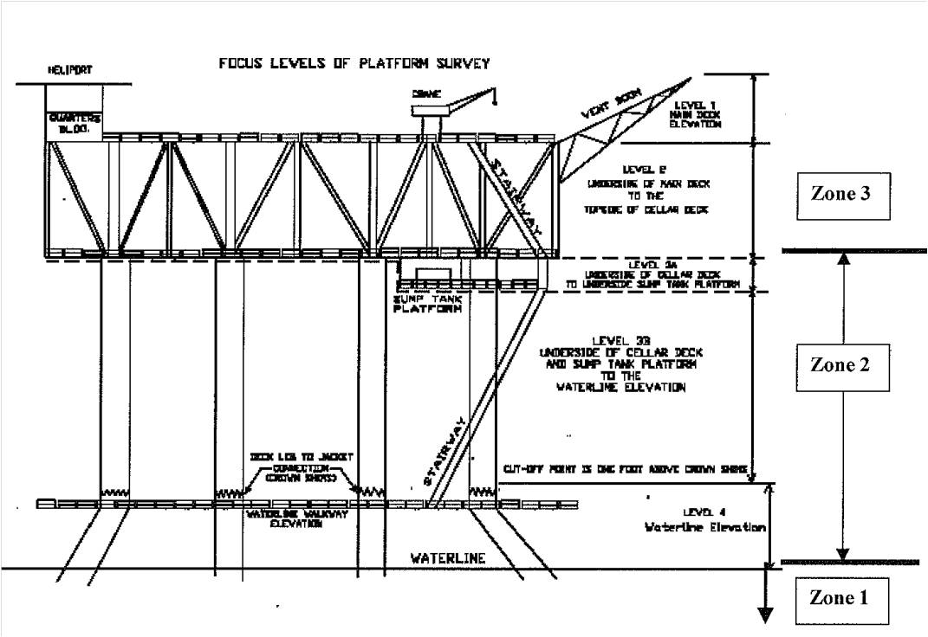

NOTE: Areas that extend outward or that are elevated above Zone 3 (e.g. flare or vent boom, crane boom, rig frame, heliport, drilling derrick) are considered Zone 2.

|  |  |
| --- | --- |
| Figure 2 Semi-Submersible Drilling Rig Zones |  |

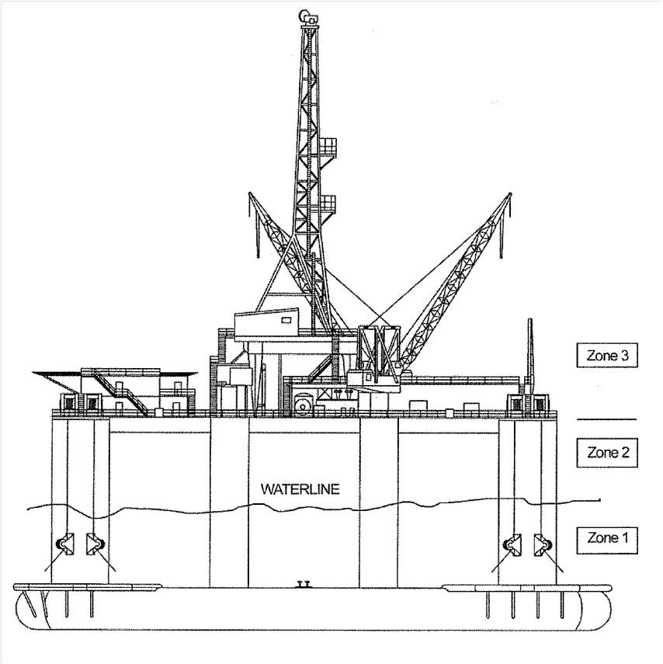

NOTE: Areas that extend outward or that are elevated above Zone 3 (e.g. flare or vent boom, crane boom, rig frame, heliport, drilling derrick) are considered Zone 2.

|  |  |
| --- | --- |
| Figure 3 Drilling Ship Zones |  |

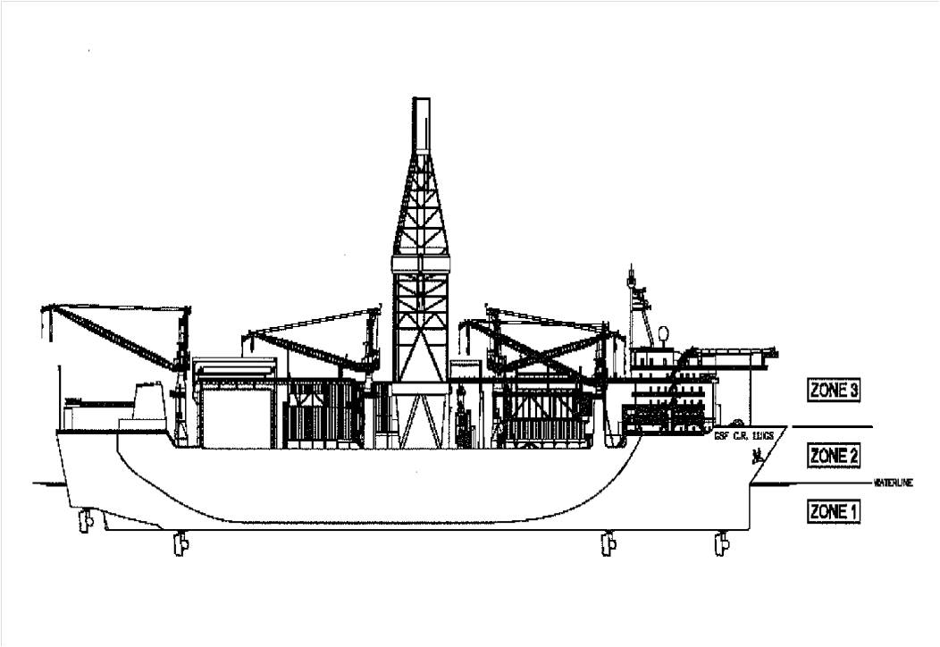

NOTE: Areas that extend outward or that are elevated above Zone 3 (e.g. flare or vent boom, crane boom, rig frame, heliport, drilling derrick) are considered Zone 2.

|  |  |
| --- | --- |
| Figure 4 Floating Production Storage and Offloading/Offtake facility (FPSO) Zones |  |

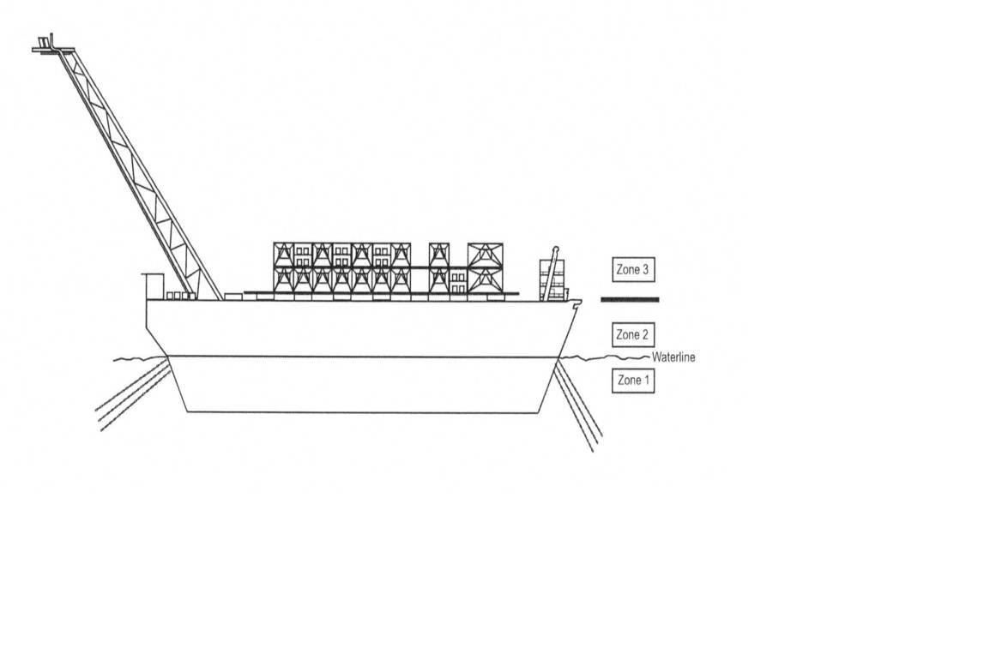

NOTE: Areas that extend outward or that are elevated above Zone 3 (e.g. flare or vent boom, crane boom, rig frame, heliport, drilling derrick) are considered Zone 2.

|  |  |
| --- | --- |
| Figure 5 SPAR Zones |  |

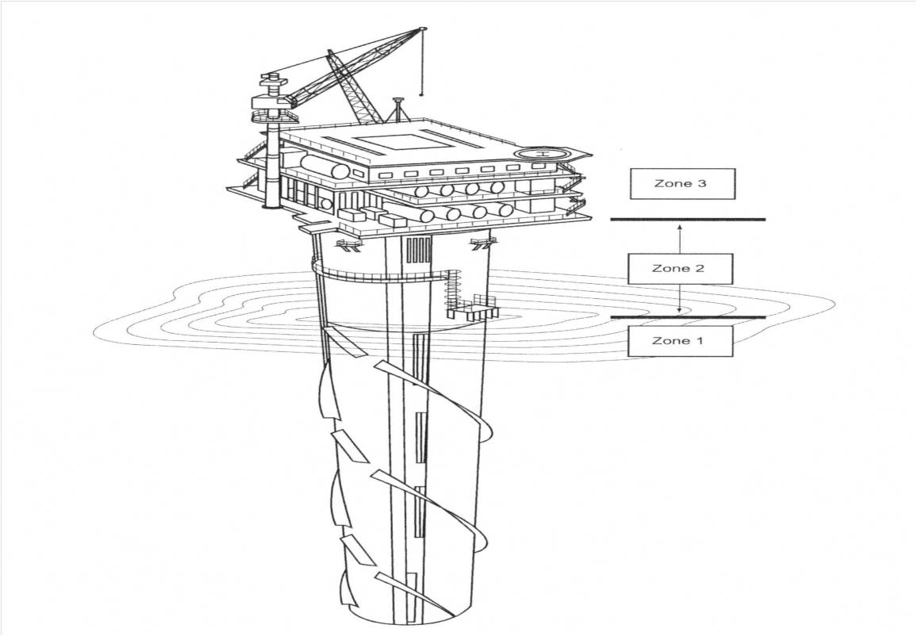

NOTE: Areas that extend outward or that are elevated above Zone 3 (e.g. flare or vent boom, crane boom, rig frame, heliport, drilling derrick) are considered Zone 2.

|  |  |
| --- | --- |
| Figure 6 Tension Leg Platform (TLP) Zones |  |

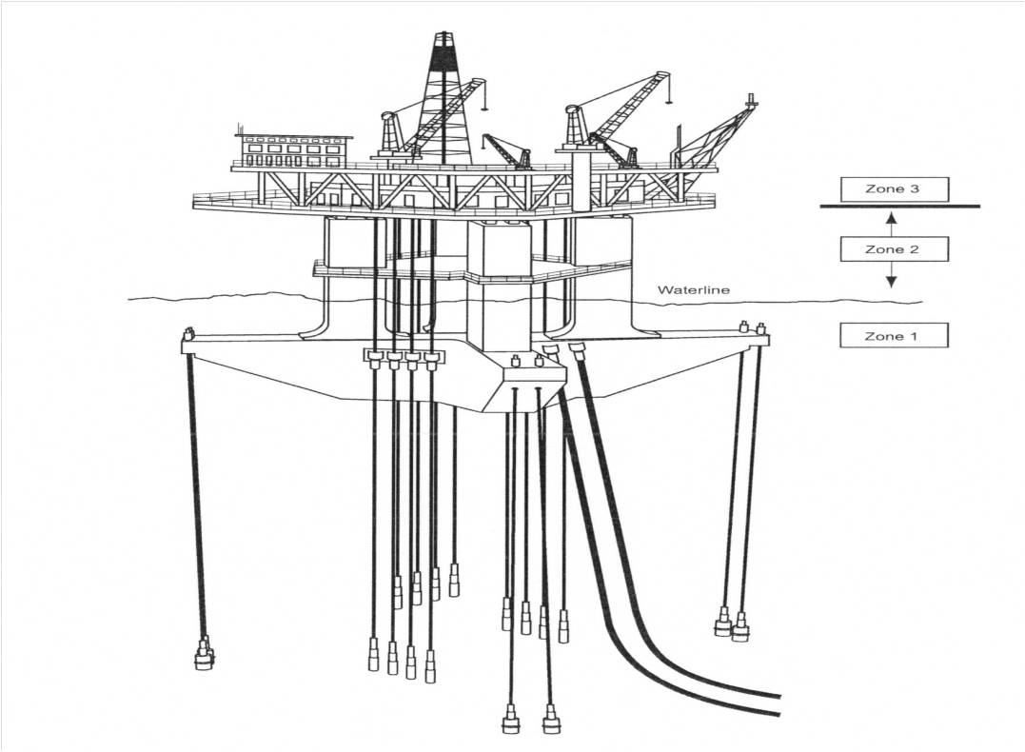

NOTE: Areas that extend outward or that are elevated above Zone 3 (e.g. flare or vent boom, crane boom, rig frame, heliport, drilling derrick) are considered Zone 2.