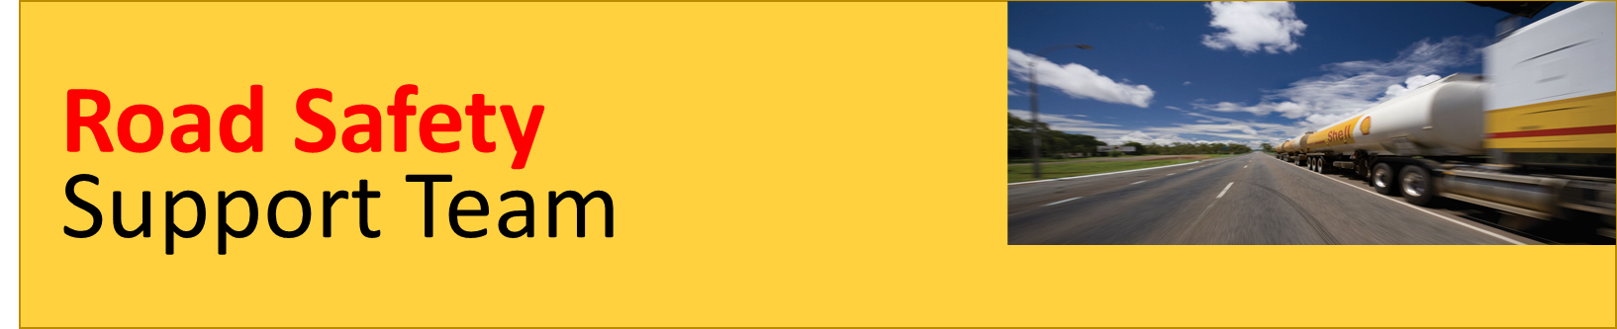
Document  Title | Journey Management Assessment (JMA) guidance
Revision date | Revision  Number | Reason for revision | Subject Matter Expert | RS Support Team Endorsement
11-07-2018 | 1.0 | Issued for use | RS team | Bernd Marx
Driving for work is the riskiest activity that most employees will face. Take a few minutes to confirm you and your vehicle are prepared for the journey, even if it’s short trip.
Note: There is neither a requirement to print/fill out this checklist nor to maintain a record of your JMA.
Please think through the following points carefully prior every trip.

Consider Your Options: The safest option is to not travel at all. Before you get behind the wheel, consider whether you need to make the trip. If travel is necessary, consider the alternatives to driving.
 | Yes No
  I have considered the alternatives to travel – online meeting, telephone call, e-mail, video conference – but have determined that it is necessary to travel to attend an in-person meeting.
 | Yes No
  I have considered travel options – air, bus, walking, cycle, public transport – and decided that driving is the optimal way to get to where I need to go.
The Driver Is Prepared: Human error is a significant factor in most incidents. Reduce the risk that you could make a costly driving mistake by ensuring you are physically and mentally prepared.
 | Yes No
  I have had a good night’s rest. I am feeling well-rested, have a positive state of mind, and am ready to undertake this journey.
 | Yes No
  I am fit to drive. I am not under the influence of drugs, alcohol or prescription medications that may impair my ability to operate the vehicle.
 | Yes No
  I will not drive for more than 10 hours or a combination of Work Related Activities for more than 14 hours or a combination of Work Related Activities and driving for more than 12 hours in Road Safety High Risk Countries. If my trip is more than two hours, I have allotted time in my schedule to stop stretch my legs, have a snack and hydrate.
 | Yes No
  My employer, customers and clients are aware I will be unavailable to answer calls, texts or emails while driving.

The Vehicle Is Prepared: A “fit for purpose”, properly equipped, well-maintained vehicle will minimize the likelihood that a mechanical failure will delay your journey, or contribute to a motor vehicle incident.
 | Yes No
  I have inspected the vehicle and confirm it is in good working order. There are no defects that must be repaired before I can operate the vehicle.
 | Yes No
  The vehicle is appropriate for the journey, and equipped for the weather and road conditions I may encounter.
 | Yes No
  I have inspected the vehicle (incl. tires) and confirm it is in good working order. There are no defects that must be repaired before I can operate the vehicle.
 | Yes No
  I have a cell phone, an emergency kit, my driver’s license and appropriate insurance coverage for business use.
A Journey Plan Is in Place: Planning ahead reduces your stress level and leaves you free to concentrate on driving.
 | Yes No
  I know where I am going, and the route I will take. I have identified an alternate route in case I encounter unexpected traffic delays, road closures or poor driving conditions.
 | Yes No
  My employer (or co-worker) knows my route, my destination and when I will be traveling. I have a communication plan in case it is required and all calls will be diverted during my drive.
 | Yes No
  I have checked local traffic, weather and road conditions (e.g. local radio).

