HSE0172-PR01

DW-GOM Contractor Short Service Employee (SSE) Policy

Purpose
This Policy ensures that contract personnel with less than six months experience in their company and or new to their job role(s) are identified, supervised, and managed. Contractors will verify that each employee has the skills and knowledge to perform their task(s) prior to their arrival to the Shell location. The intent of this policy is to prevent injury or harm to personnel, property and the environment.

SSE
Any contractor personnel with less than six months service with their present employer and or new to their job role(s) will be considered an SSE. A “Contractor SSE Form (Appendix A)” must be completed by the contractor for each individual SSE prior to start of work. All SSE personnel will be required to have a conversation with the Ultimate Work Authority (UWA) or Designee regarding their scope of work, associated risks, and expectations prior to start of work. Shell contractors will manage their SSEs in alignment with this, or a materially equivalent policy. This policy does not apply to escorted visitors and inspectors on a Shell location who are not performing regular work.

All SSEs must:
- Attend a location-specific HSE orientation prior to beginning work on location. Applicable contractor and Shell HSE Policies shall be discussed during the orientation.
- Be assigned an experienced mentor by the Contractor to assist the contractor personnel during his/her “SSE period.” It is the mentor’s responsibility to closely supervise the assigned SSE and prevent him/her from performing tasks for which they are not properly trained.
- Be identifiable by location’s agreed method (e.g., Green Hard Hat, SSE Tape on Hard Hat, etc.).
Subcontractor SSE Management
Shell contractors will manage their sub-contractors in alignment with this policy or a material equivalent. Shell will audit the contractor’s SSE programs as part of the Pre-Qualification or Contractor HSSE Management review process.

Following are Shell’s SSE Crew requirements:
For purposes of this policy, a “crew” is defined as those contractor employees working at a single location and employed by the same contractor. Any exceptions to these requirements must have approval by the location’s UWA or Designee. If a Variance is sought for an individual or group, Contractor SSE Form (Appendix B) shall be completed.
Crews with 4 persons or less:
- Single person “crew” cannot be a SSE.
- 2-4 person crews can have only 1 SSE per crew.
Crews with 5 persons or more:
- 5 or more person crews can have < 20% SSEs per crew.
Contractors New to Location:
Contractor personnel who are new to a location must have a conversation with the UWA or their Designee. Based on the conversation, the UWA or Designee has the authority to determine whether the contract employee will or will not be included in the SSE program. If the UWA or Designee determines that the contractor needs to be included in the SSE program, a Contractor SSE Form (Appendix A) shall be completed. Factors to consider include, but are not limited to:
- Job responsibilities/duties from previous assignments, work processes/practices from previous assignments, equipment/tools from previous assignments, competency/training, skill level, and familiarity with co-workers.

Removal from the SSE program
To be removed from SSE status, a contractor employee must exhibit safe behavior for six months and have a general awareness and working knowledge of the contractor’s and Shell’s HSE policies as found in www.shellcontractor.com, and documented on Contractor (SSE) Form Appendix A. Contractors may recommend a reduction of the six-month requirement based on the contractor’s performance and relevant industry experience. This reduction must be approved by the UWA/Designee and documented on Contractor (SSE) Variance Form Appendix B.

Early Removal or Contractor SSE Variance
Early Removal or Variance to Shell’s SSE Policy can only be granted by the written approval of the location’s UWA/ Designee [documented on Contractor (SSE) Variance Form Appendix B].

Contractor SSE Decision Flowchart
The flowchart below explains the overall SSE process and decision points that will be made regarding contractor personnel SSE status.
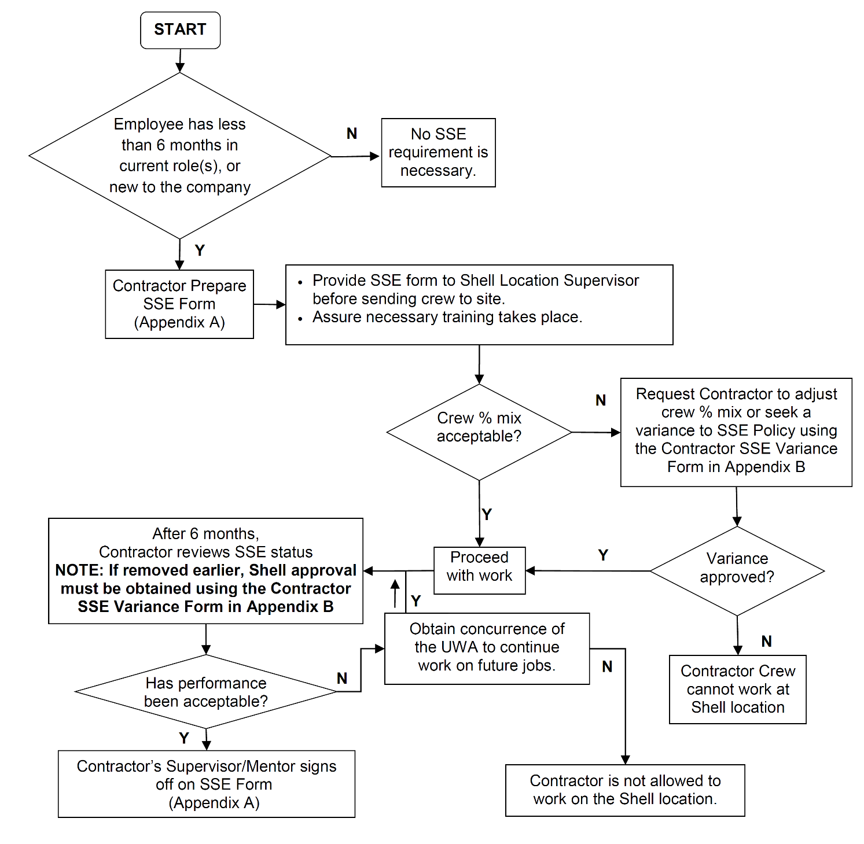
HSE0172-PR01-TO.01 Contractor Short Service Employee Form Appendix A
This form must be completed by the contract company and submitted to the Shell location supervisor prior to sending crew to location.

Company: | Date:
Working as a sub-contractor: (☐) Yes (☐) No
SSE Name: | Years Oil Field Experience:
Date of Employment: | Experience in Present Position: | Years:
 |  | Months:
Who has been assigned as the SSE mentor (if applicable)?
Employment Record: (Last 3 years)
Previous Employer(s) | Start Date |  | Departure Date
List all completed mandated training for role(s):

*Training certificates shall be readily available upon request
List all current training gaps required for the role(s):
This portion to be completed by worker during conversation with Shell representative
- I have been trained, skilled, and knowledgeable to safely perform my task(s). |  |  |  | ☐Yes | No ☐
- I understand and have been given an orientation to the location and understood expectations. |  |  |  | ☐Yes | No ☐
- I understand the Shell Life Saving Rules, who the UWA is, and expectations of Stop Work Authority. |  |  |  | ☐Yes | No ☐
- I understand expectations around fatigue and fitness to work. |  |  |  | ☐Yes | No ☐
Review and Approval
Worker: | Sign Here |  | Date
Contractor’s Supervisor/Mentor: | Sign Here |  | Date
Shell Representative: | Sign Here |  | Date
If restrictions are identified, list here:
Contractor’s Supervisor/Mentor approval to remove SSE from Program after 6 months | Sign Here |  | Date
HSE0172-PR01-TO.02 Contractor Short Service Employee (SSE) Variance Form
Appendix B

This form must be submitted to the Shell UWA/Designee for Approval of Early Removal or Variance to the SSE Policy. Form below may be used for a contract employee or a group of contract employees.

Select Early Removal or Variance in the drop down option of the Action column for each name
Name | Company | Action | Justification | UWA/Designee Approval
 |  | Select Action |  | Select Approve or Reject
 |  | Select Action |  | Select Approve or Reject
 |  | Select Action |  | Select Approve or Reject
 |  | Select Action |  | Select Approve or Reject
 |  | Select Action |  | Select Approve or Reject
 |  | Select Action |  | Select Approve or Reject
 |  | Select Action |  | Select Approve or Reject
 |  | Select Action |  | Select Approve or Reject
 |  | Select Action |  | Select Approve or Reject
 |  | Select Action |  | Select Approve or Reject
 |  | Select Action |  | Select Approve or Reject
 |  | Select Action |  | Select Approve or Reject
 |  | Select Action |  | Select Approve or Reject
 |  | Select Action |  | Select Approve or Reject
 |  | Select Action |  | Select Approve or Reject
 |  | Select Action |  | Select Approve or Reject

UWA/Designee Signature: | Date:

